Bandit Level 3
DG Interns Hub | Week 1 | OverTheWire Bandit Writeup

Objective
Read a filename containing spaces.

Activity summary
Suggested learning command / approach: cat "spaces in this filename". Use only on the authorized OverTheWire training environment.

Key learning
Quoting filenames with spaces.

Evidence
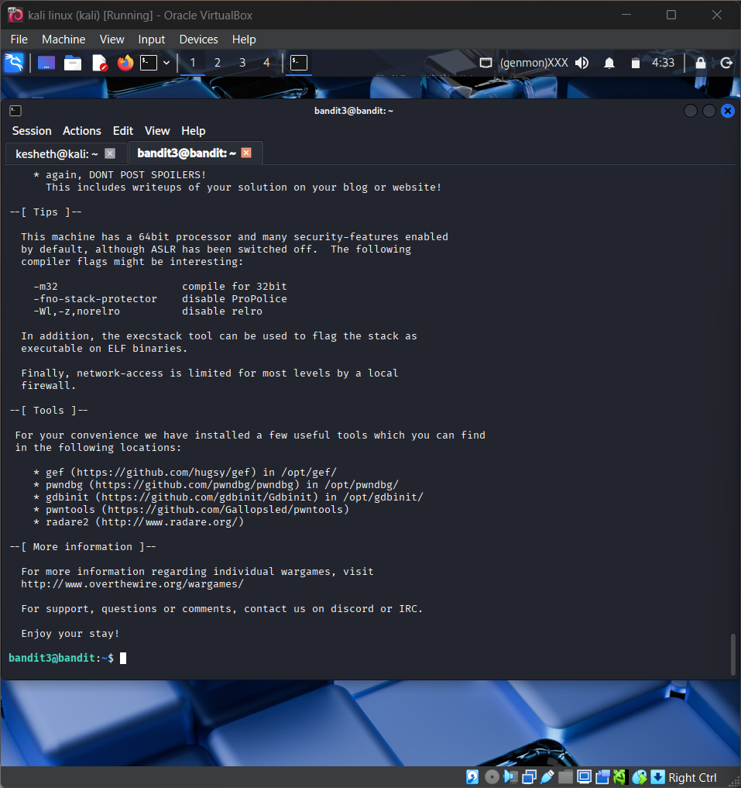
Screenshot: Bandit_Level_3.png
The screenshot is evidence of level activity/login; it may not show every solution step. No passwords are reproduced.

